**Assignment 2**

1. Create tables **“Author”** and **“Book”** with following data. *AuthorID* in *Book* table should be a foreign key which should refer *AuthorID* column of *Author* table.

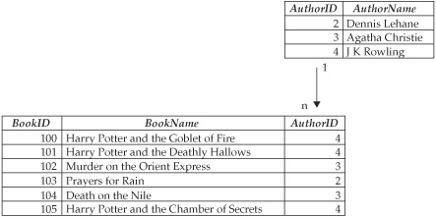

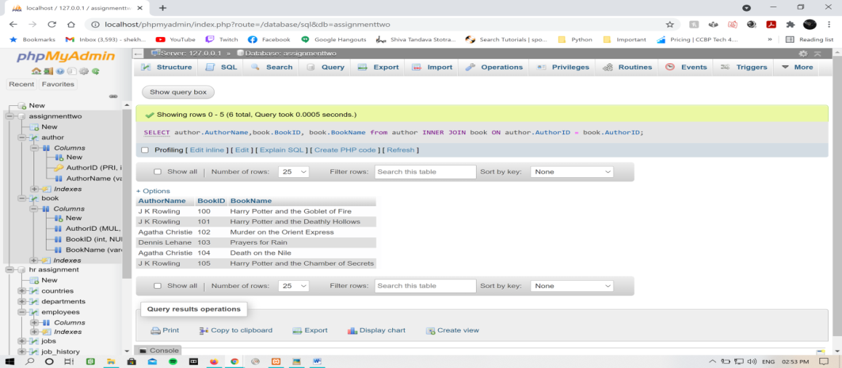

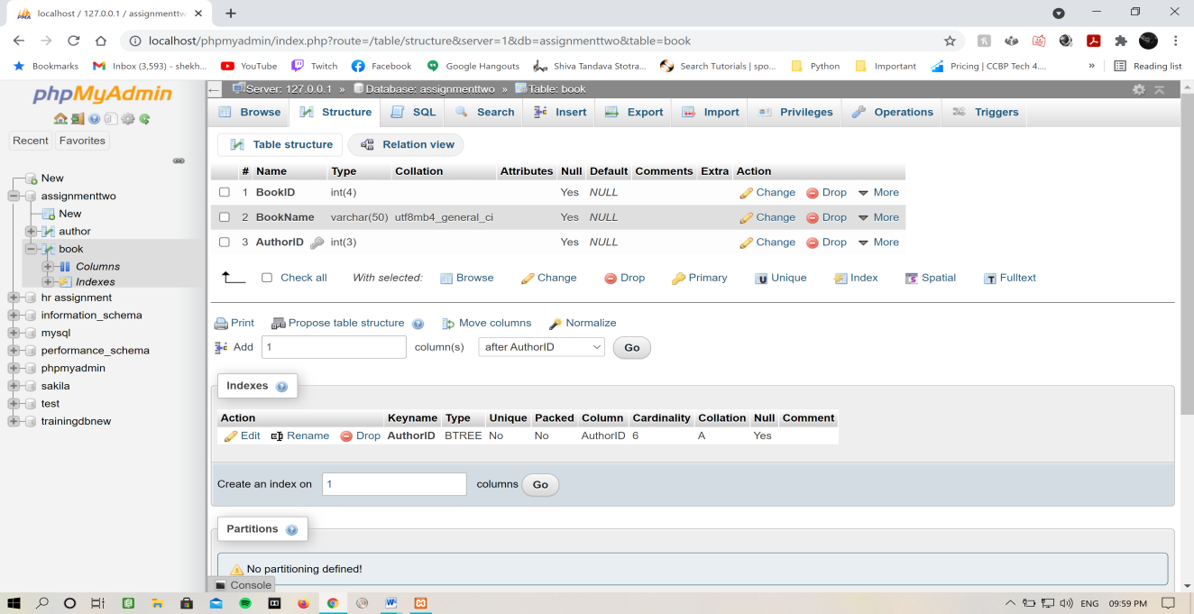

1. **Import tables and data from *hr.sql* file and solve the following queries:**
   1. Find highest salary for each department

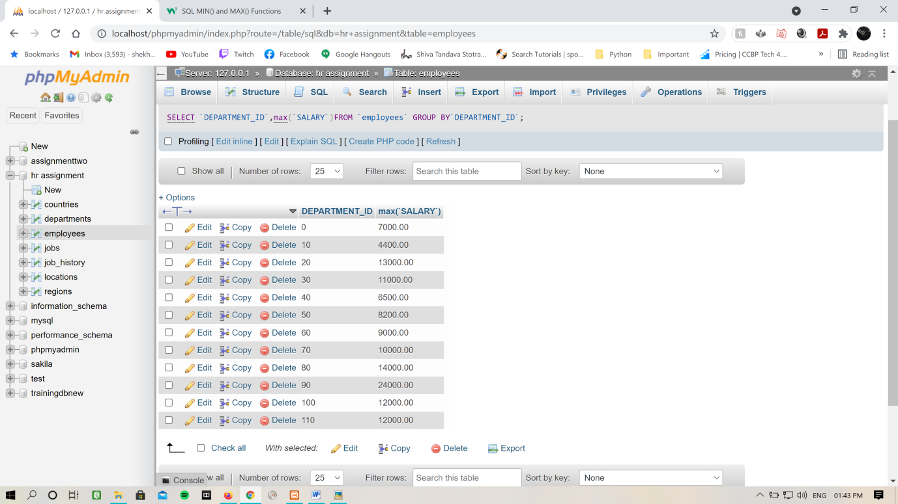

* 1. Find lowest salary for each department

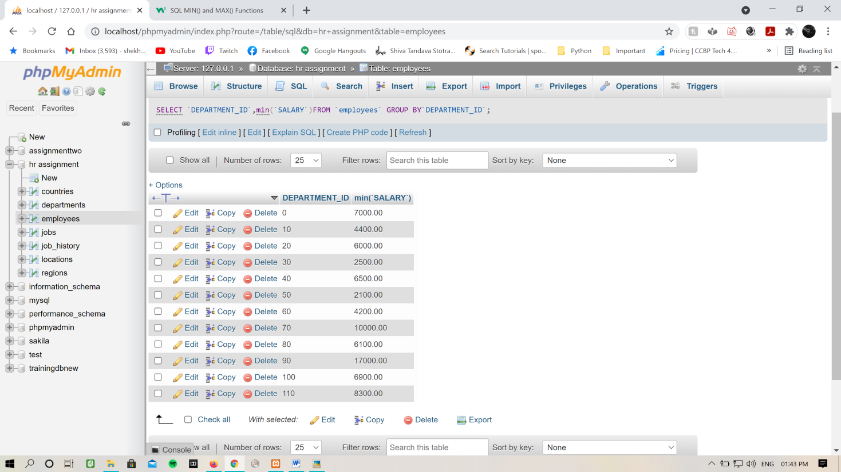

* 1. Display id and number of employees for all the departments in which more than 10 employees are working

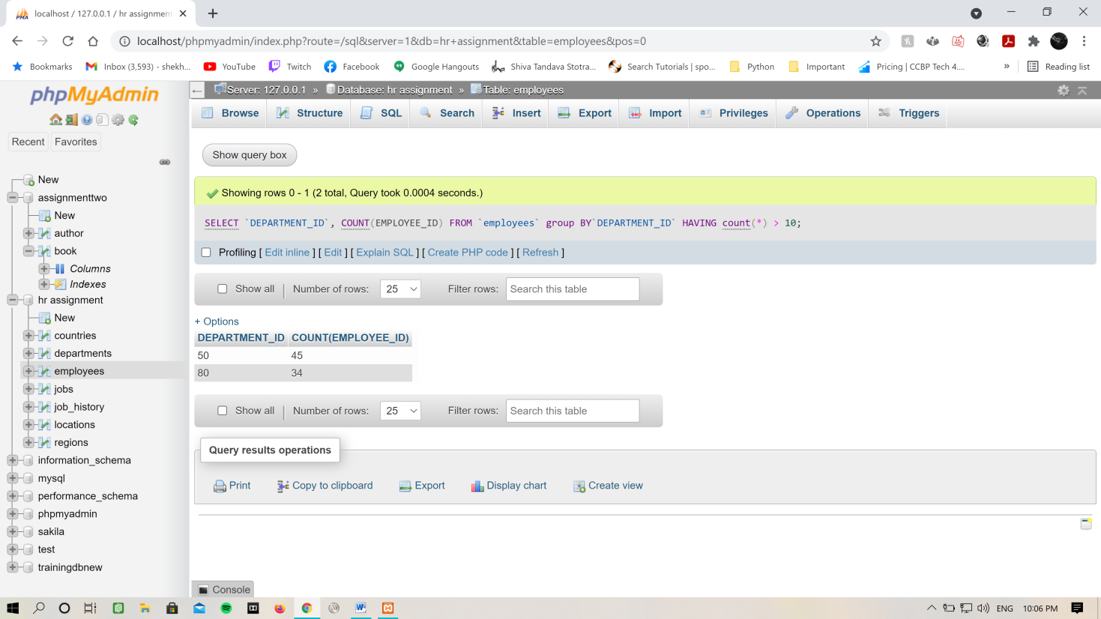

* 1. Display first name, salary and department id of all the employees whose name starts with a or d and earns more than 10000 and hired after 1st June 1987

